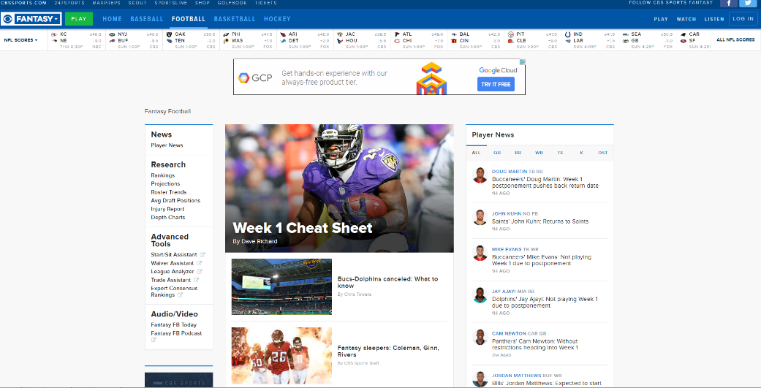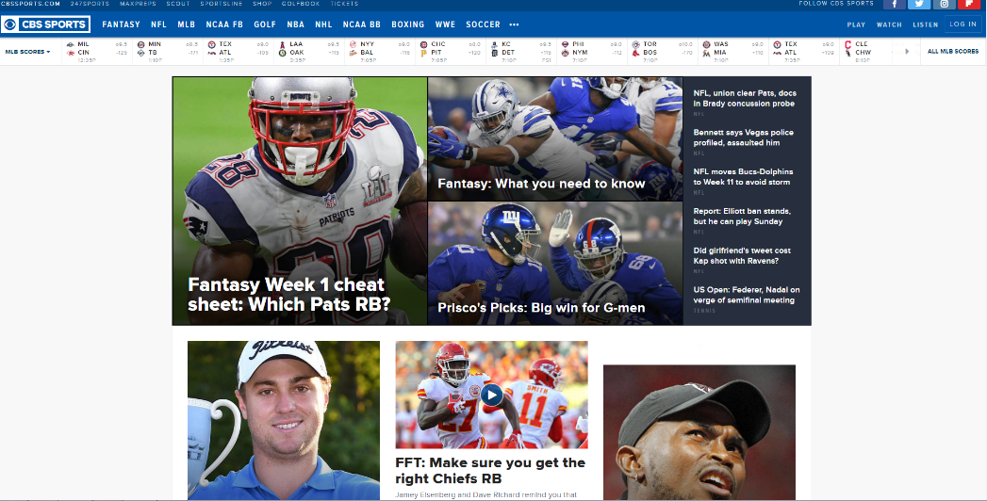

Jake Lorah

I visit this site, CBS Sports, often because it shows all the sports scores for every team in a clean and organized view. Some things I like about this site are its neatness, organization, and the fact that it doesn’t overwhelm you right when you enter the website. After looking at this website, I saw features that would look good in future websites. Some of those features are the color scheme, scores tab at the top, and the attention grabbers right when you enter the site.

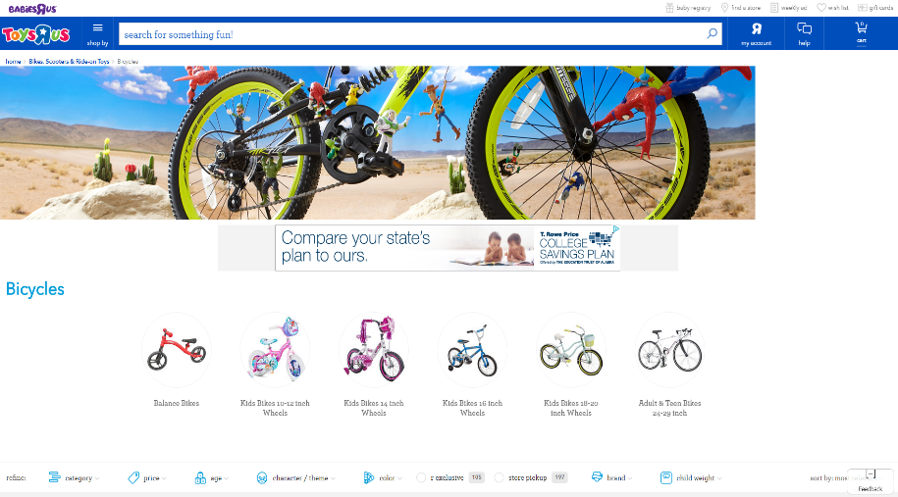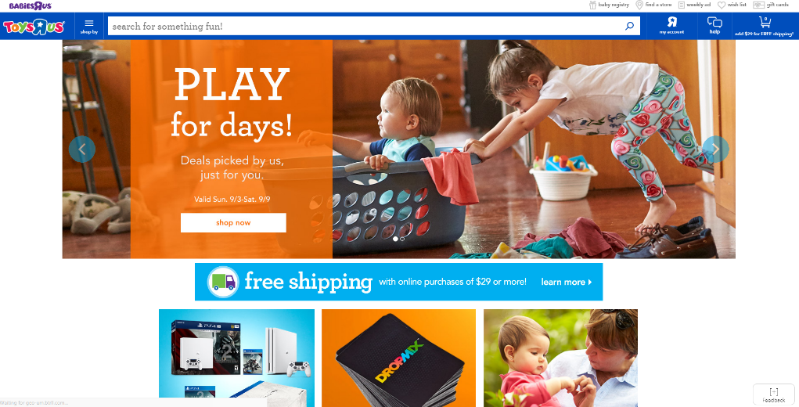

When I was in grammar school, I always went on the Toys R Us website. I always loved the website because of how organized it was. Everything is split into specific categories. I could use this website for insight of the categories breakdown. I also like the font family on the website, it stands out.

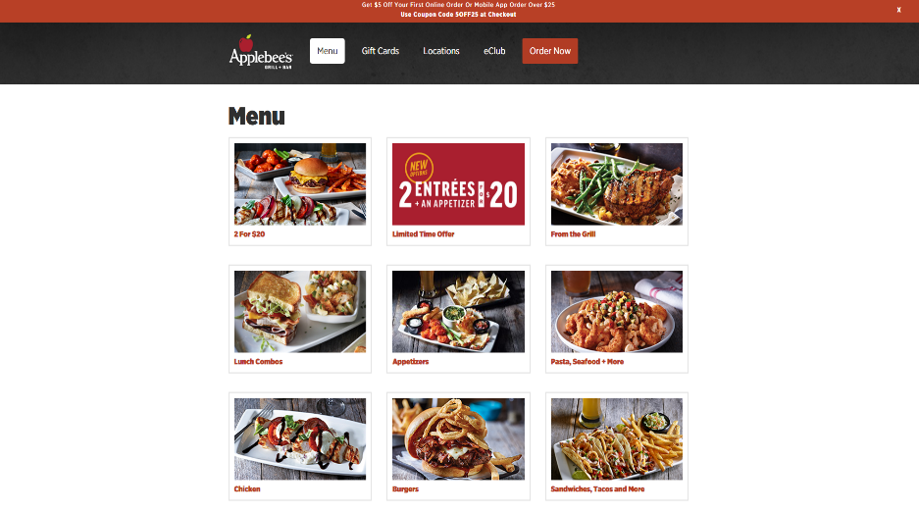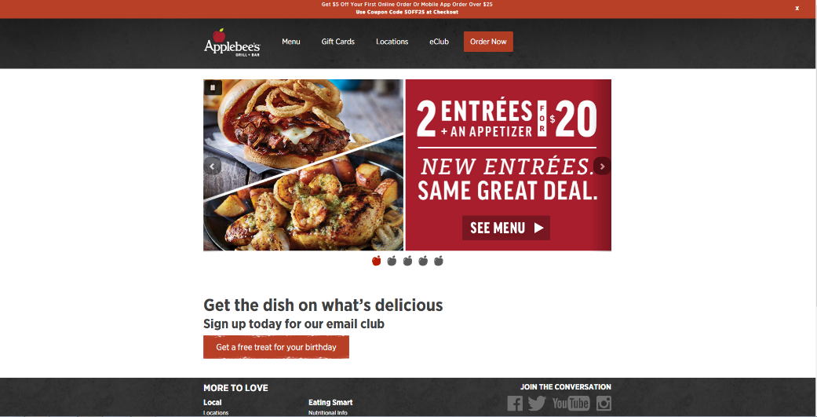

Applebee’s is a restaurant my family and I go to. I really like this website a lot because it is super clean and simple. Sometimes you don’t need a crazy website with stuff popping up all over the screen. This website has a good color scheme and it is nice and neat. This would help me with future websites, especially the tabs menu at the top and the overall structure.

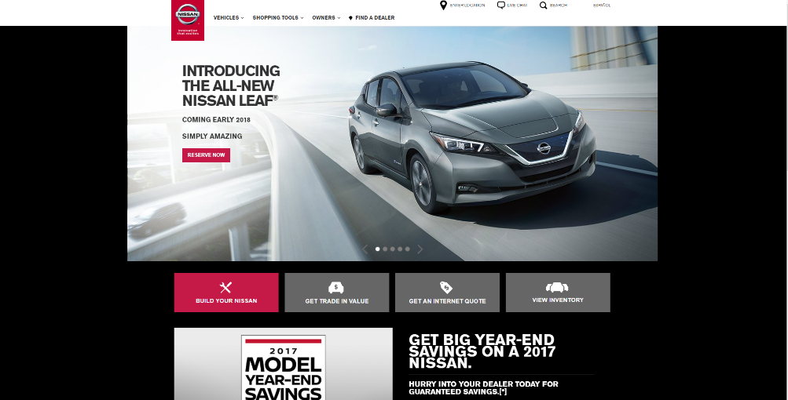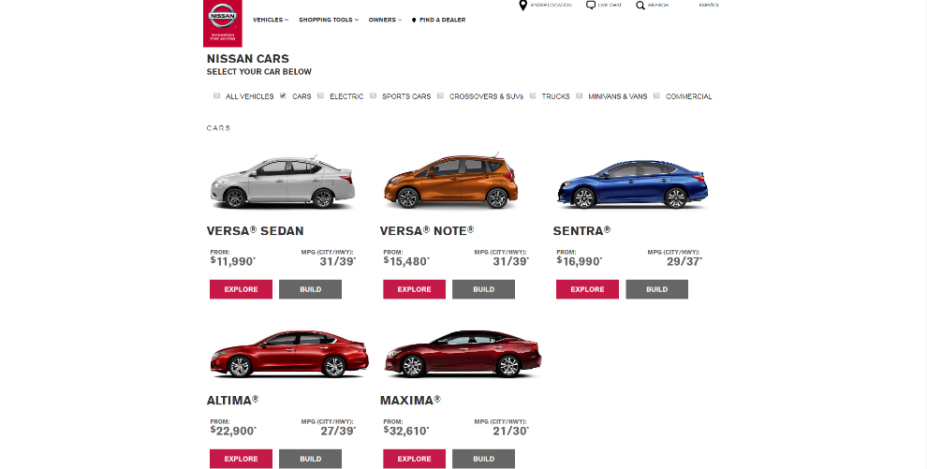

Car company websites could be very overwhelming at times, but the Nissan website to me is one of my favorites. First, it is very clean, there isn’t a thousand things on the home page itself. Second, it has a good color scheme. And last, the cars page on the website is perfect because you get the option to view the car and even build your own. This website would help me if I were selling some type of vehicle(s).

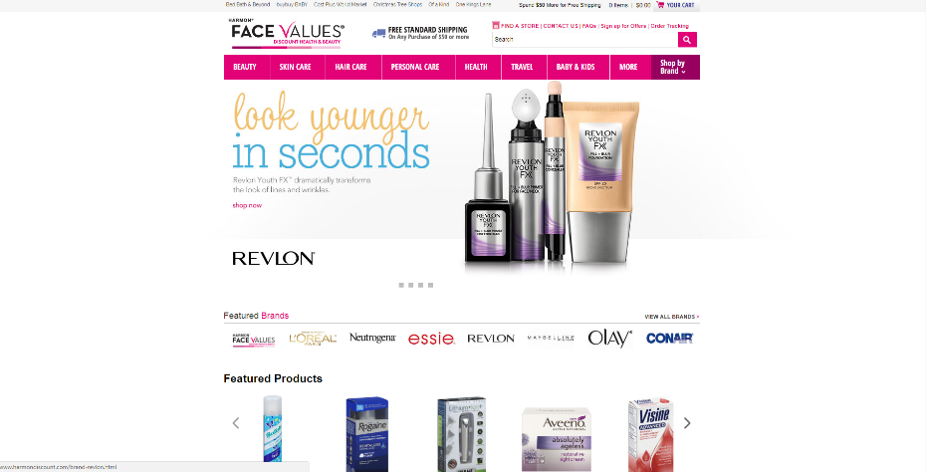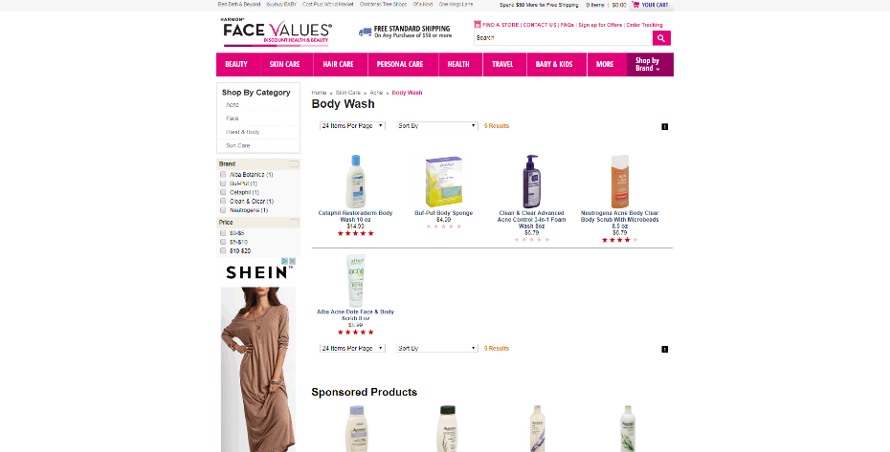

There is a Harmon’s right near my house. I like it there because they have a lot of cosmetic things, such as shampoo, lotion, cologne, and much more. I like this website because it shows the ratings under each item. Out of 5 starts how much people enjoyed the product. That is always nice to see when online shopping because you could see if the product is worth buying.

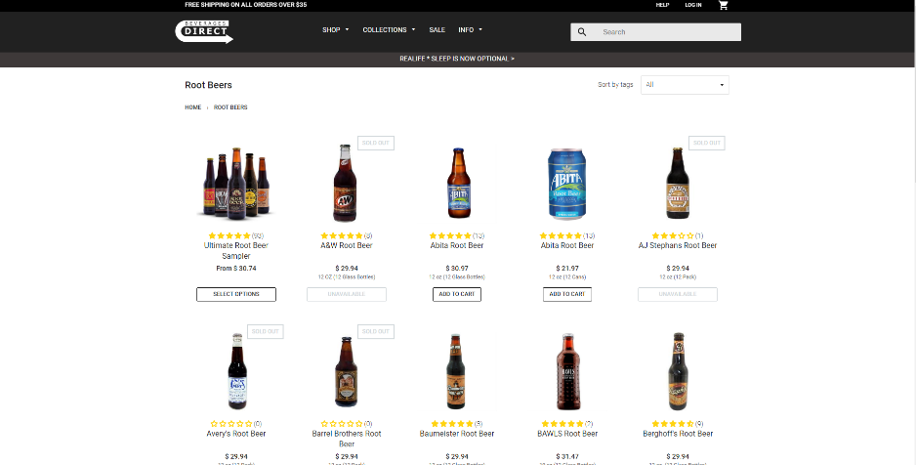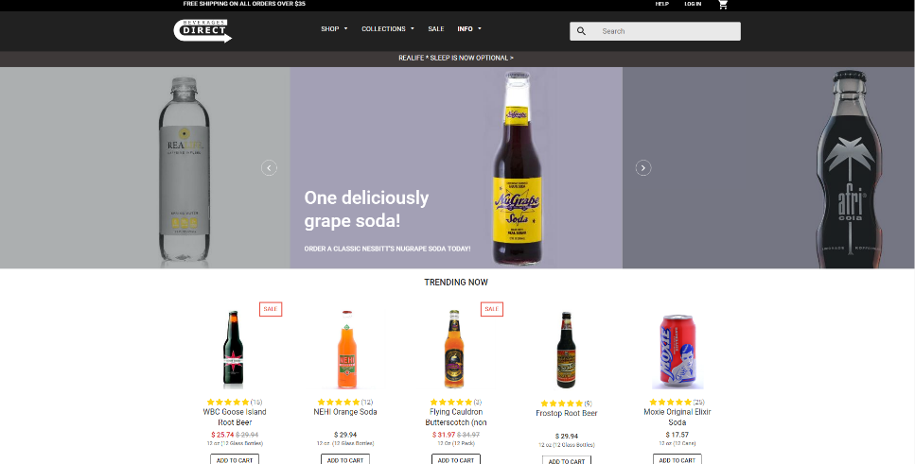

This website, Beverages Direct, is also one of my favorites. On this website, you could buy drinks in glass bottles. I like buying sampler packs on here and trying all different kinds of soda. I like this website because of the color scheme, black and white. I like how simple it is. You don’t need crazy colors for your website. Just the simplest colors could increase customer satisfactory on the website. This website would help with picking out the color scheme.

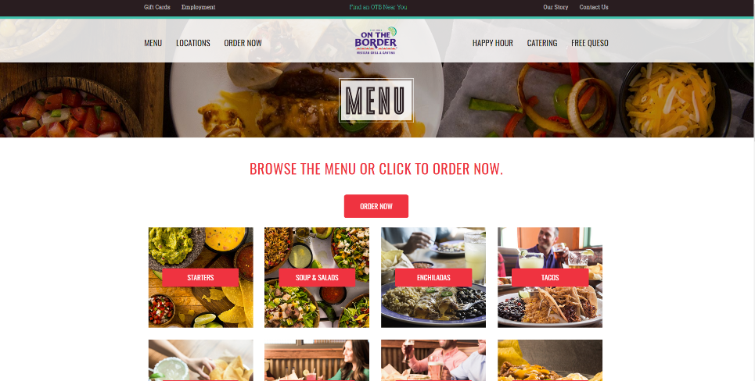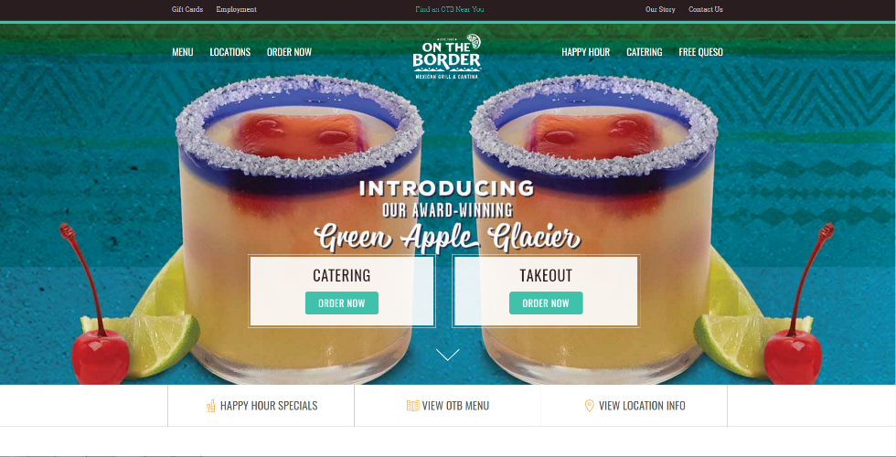

On The Border is another restaurant my family and I go to. What I like about this website is the menu part. I love how they structured it into different categories. Starters, soups and salads, enchiladas, and more. Plus, behind each category is a picture of what it may look like, examples of that food. It is just overall a nice and clean format, and this would help me in making websites with a menu on it.

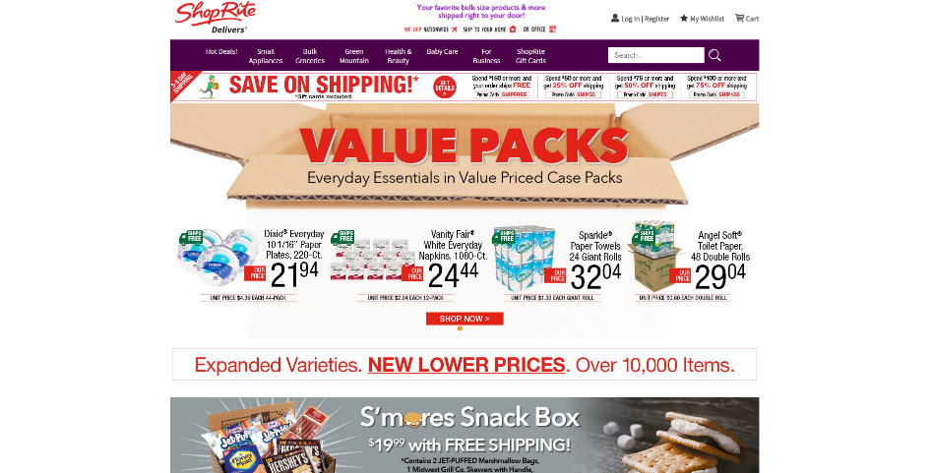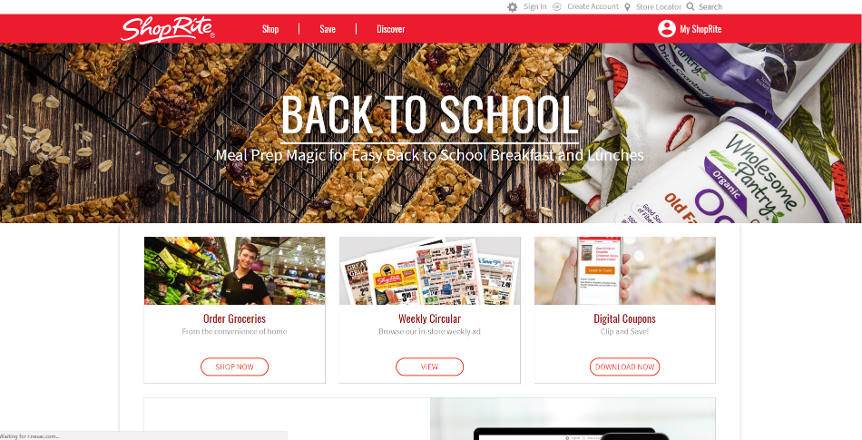

Shop Rite is our primary super market. The Shop Rite by our house is out dated, but the website is clean and easy for a grocery store. I like their website because of the online catalog. Instead of going in the store and picking up a paper copy of the catalog, it is now online, paper free! People should use the online catalog all the time. This website would help me for some kind of grocery store, with an online catalog on it.

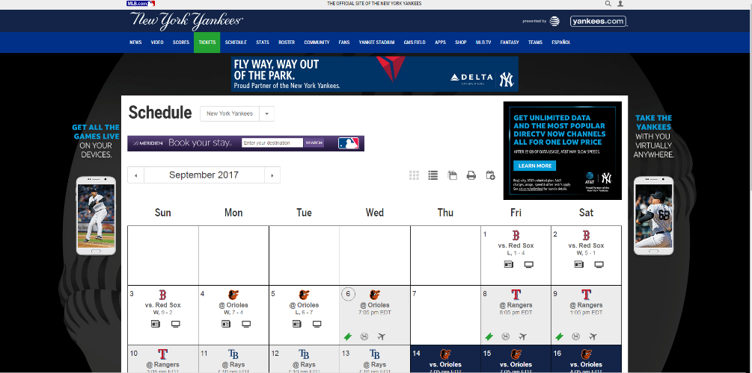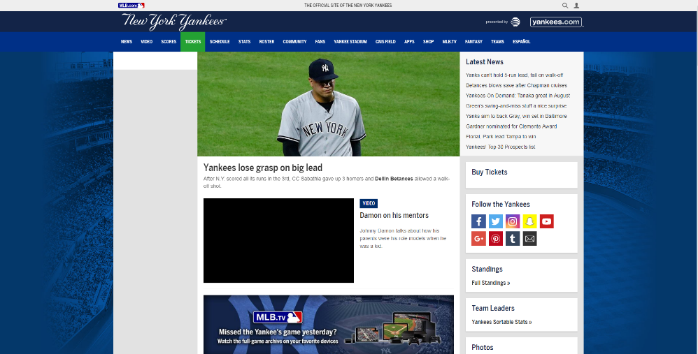

New York Yankees are my favorite baseball team. I really enjoy their website because everything on it is about the Yankees! This website is New York Yankees, and Yankees only. I like the schedule feature on the website. It organizes the games into a nice clean calendar. This makes it easier to find games. This would help me making calendars for websites.

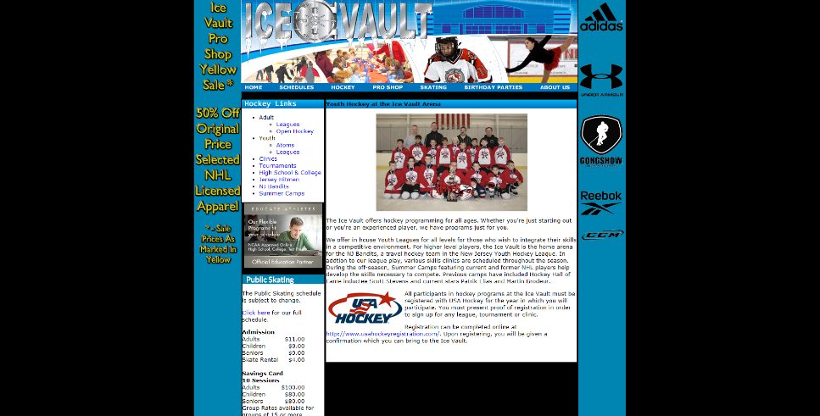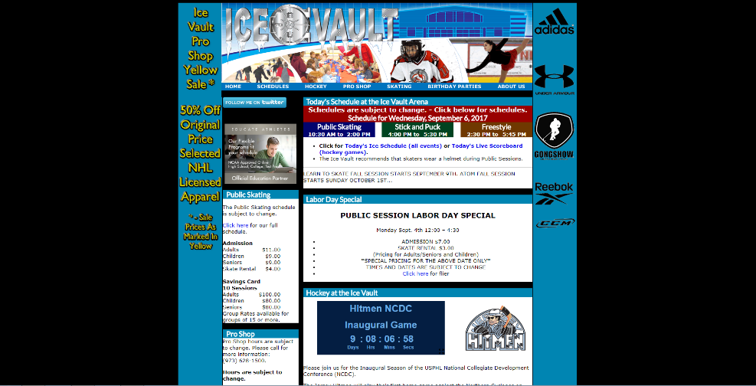

The Ice Vault is right by my house. It is an ice rink, where I play hockey at most of the times. I like their website because on the home page, they update the times for public skating, freestyle, and stick and puck each day. Instead of searching through the website, the 3 main events are right at the top of the home page. This would help with websites where we must update it often.

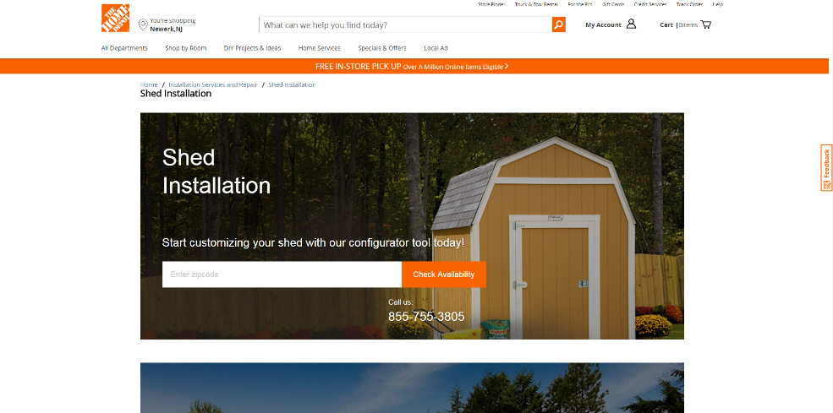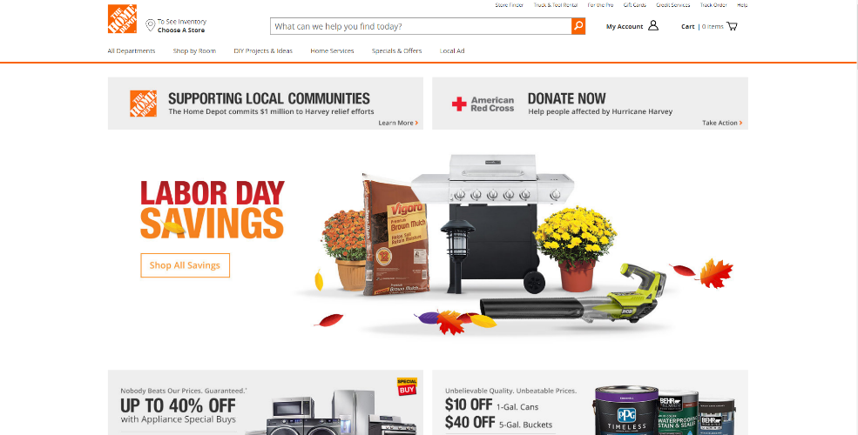

The Home Depot is our handyman place. If something around the house goes wrong, we will go to The Home Depot to get the part for it. I really like the “shed installation” page of the website, because it allows you to check the availability by entering your zip code. Once you enter your zip code, it will then tell you if someone is available to install the shed for you. That is an awesome feature that could come in real handy.

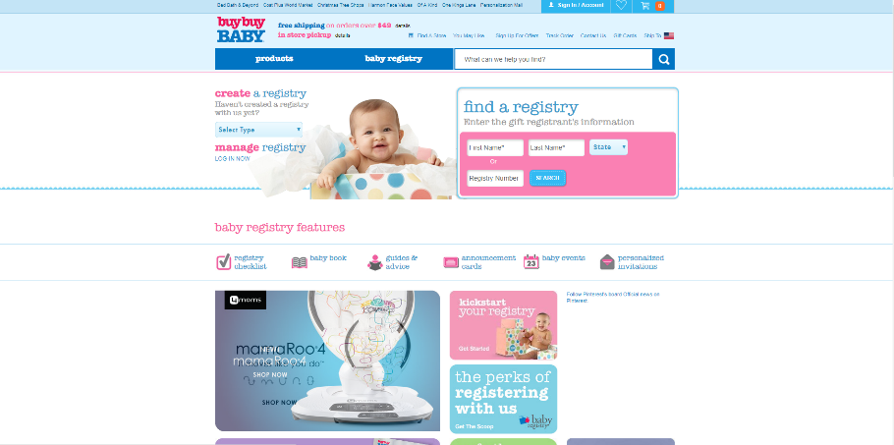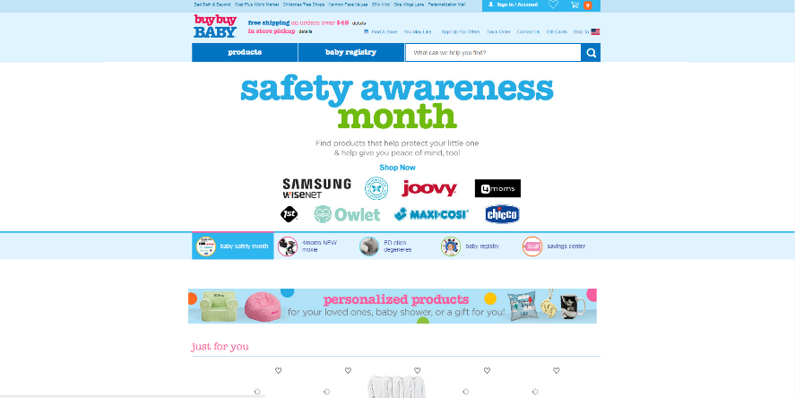

I don’t shop at Buy Buy Baby, but I do like the website it has. I really think the home page would help me with future websites because it is a clean and simple platform. It displays a message on the home page that is important, and it even gives you a “shop now” button you can click to get right into shopping. All of this is right on the home page, how great is that! This website has a nice color scheme as well.

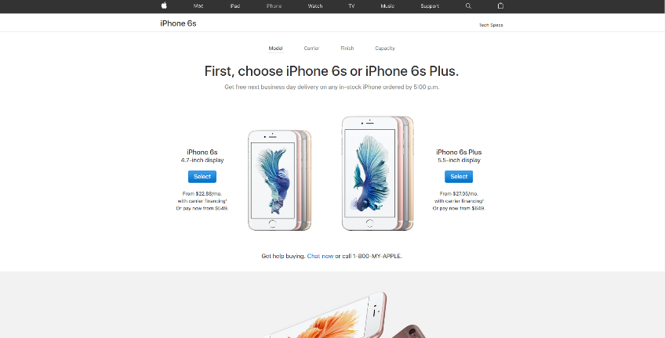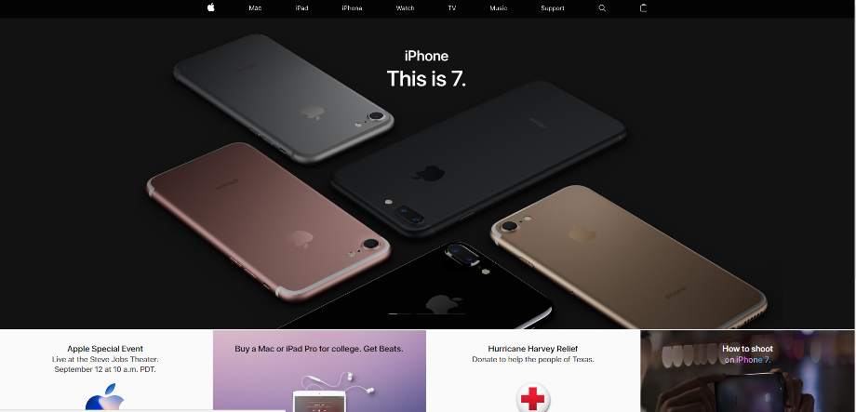

Apple is one of the biggest companies in the world. A website is super important to them, and they nailed it. I like how the home page displays the new or coming soon item everyone is talking about. That right there is an attention grabber. Also, I like how the tabs are split up into categories, so you could just click what type of item you want. This website is helpful with online shopping websites I might make in the future.

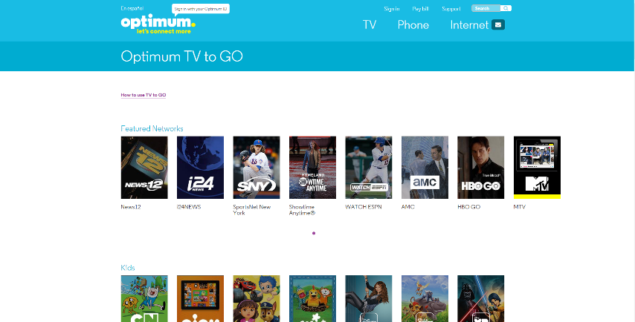 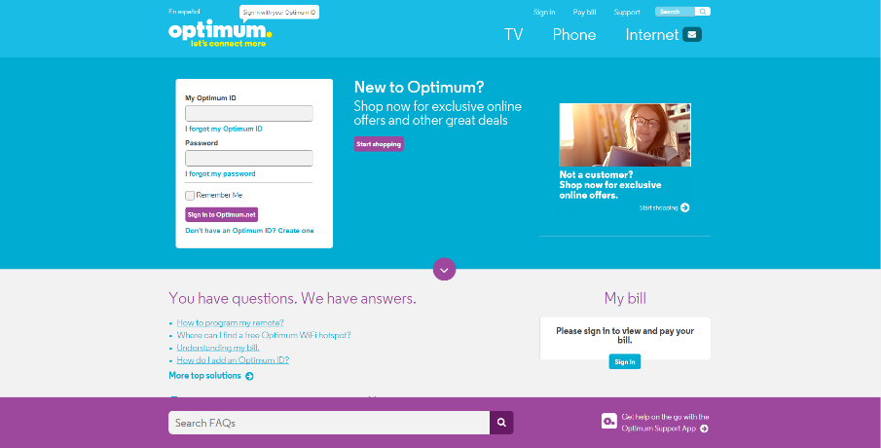

Optimum is our cable provider at our house. I really like the website because it shows the 3 main things optimum does at the top. TV, phone, and internet. I also like how it shows the Optimum TV to go channels on the website, so you know what channels you could watch on your device(s). This website has a good color scheme and is relatively neat. This would help me with finding a color scheme for a website.

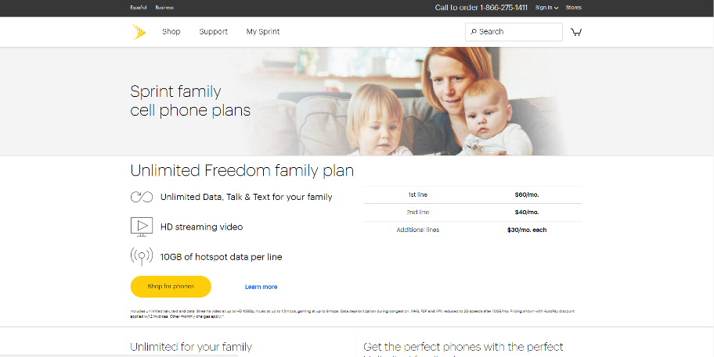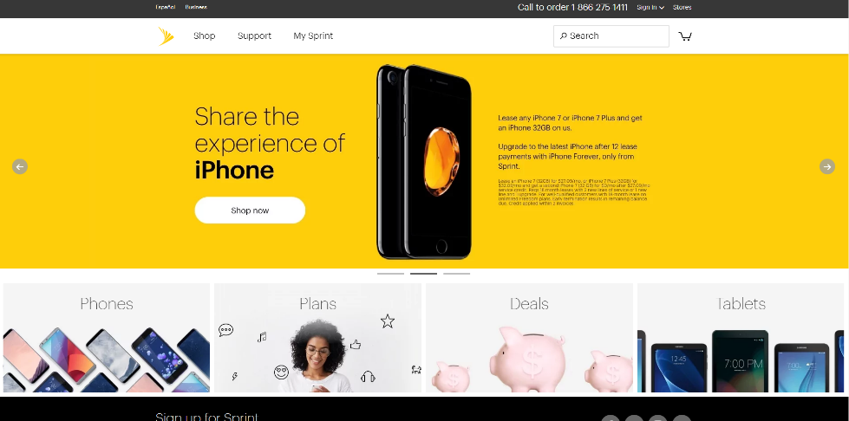

There are so many cellular companies around, it gets very overwhelming. My family and I all use Sprint. I like the Sprint website because of the color scheme mainly. White, yellow, and black, three simple colors. I feel like when you use simple colors for a website, it makes it pop and easier to read. I also like the splash pages, where they show happy and uplifting pictures, to bring a happy and family-friendly mood.

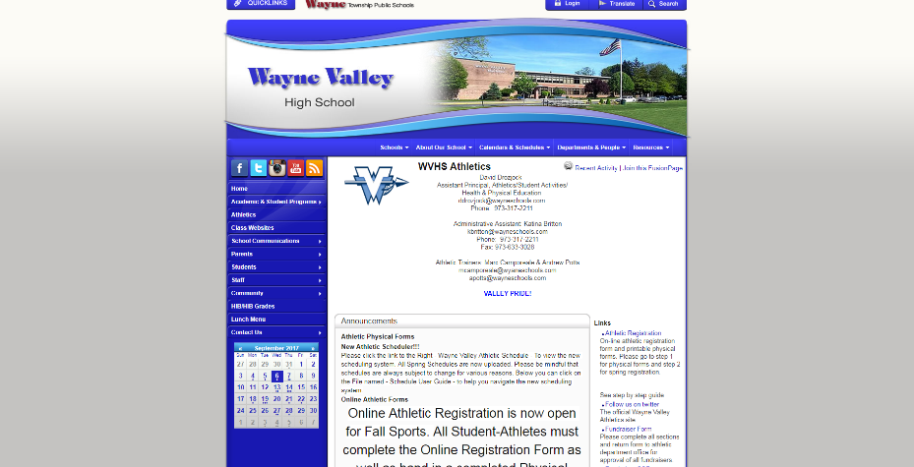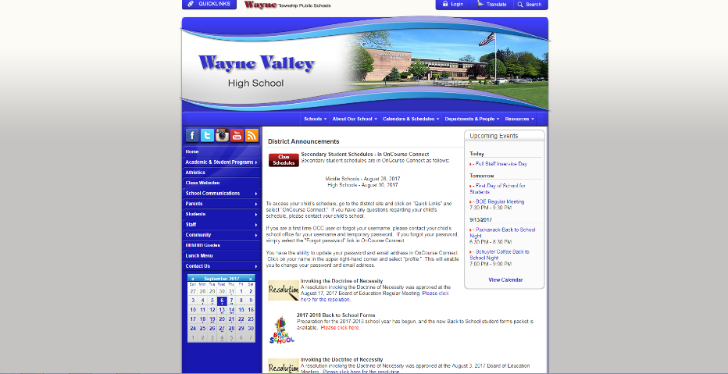

Wayne Valley High School is one of the public high schools in my town, Wayne NJ. This website is average for a school website, but what I really like about it is that you could access any other public schools website in Wayne on the website. Just click the drop box “Schools” and you could click on any other school in Wayne you want to see. That is a cool feature. I also like the color scheme, and how it blends in and symbolizes the school colors.

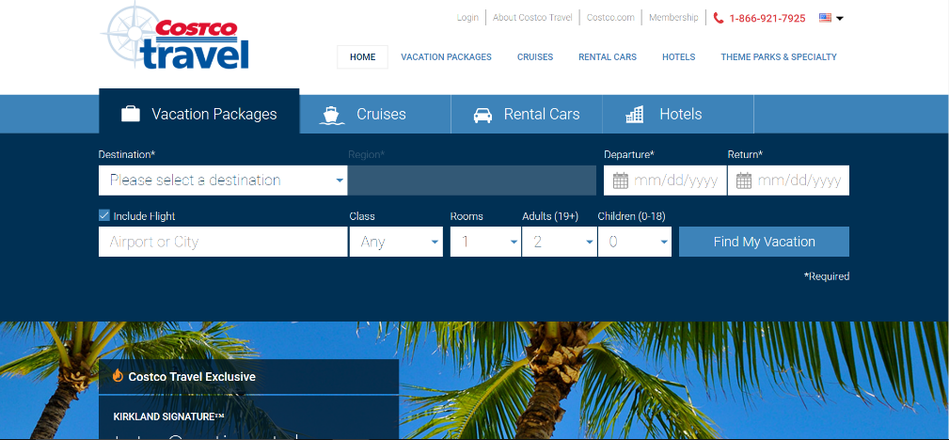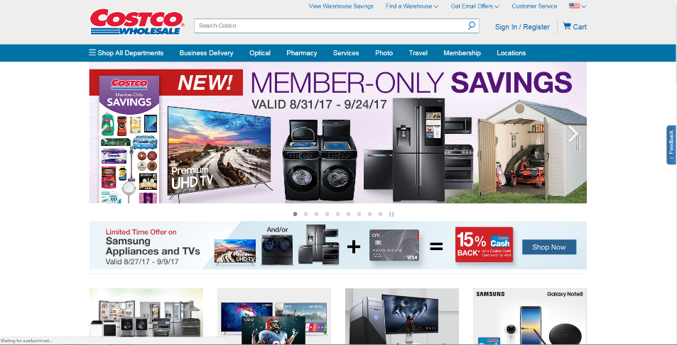

My family loves Costco, we go there so often. I absolutely love the Costco website because of how clean it is. The color scheme blends in really nicely and everything on the website is organized. I like how all of Costco’s services are on the home page. An example we use is Costco travel, a vacation booking splash page from Costco. That page is so easy to navigate through and could really help with online forms I make for websites.

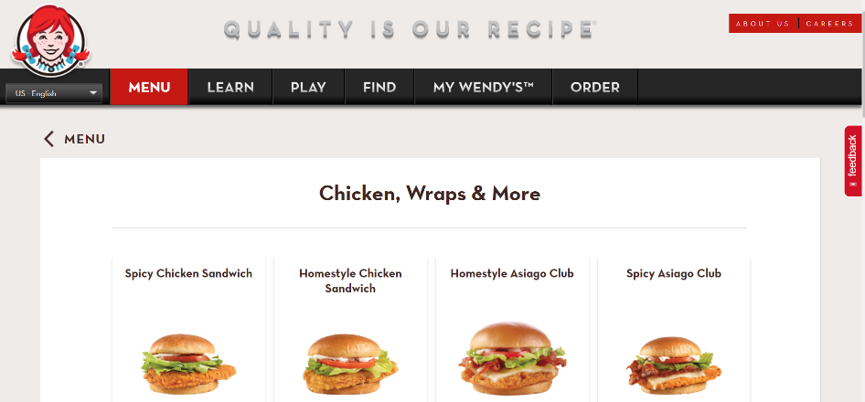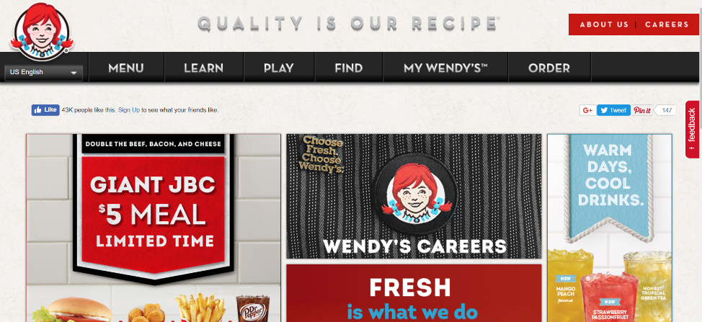

Wendy’s is a great place to go to get a quick bite. They recently just updated their website, and I love it. Color scheme is great, not crowded on the home page, and even the tabs are pretty cool. The best part about the website is the menu page, because you could see a picture of the item you want to see, and even order online! This website would help me with mixing the menu and ordering online features.

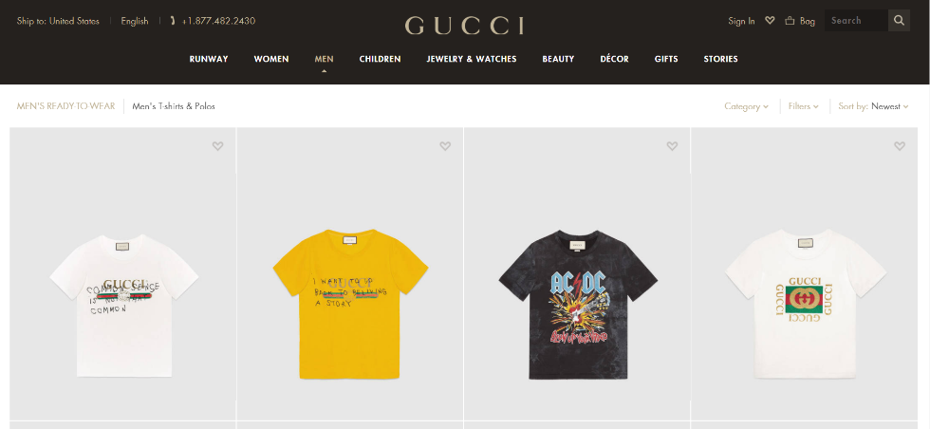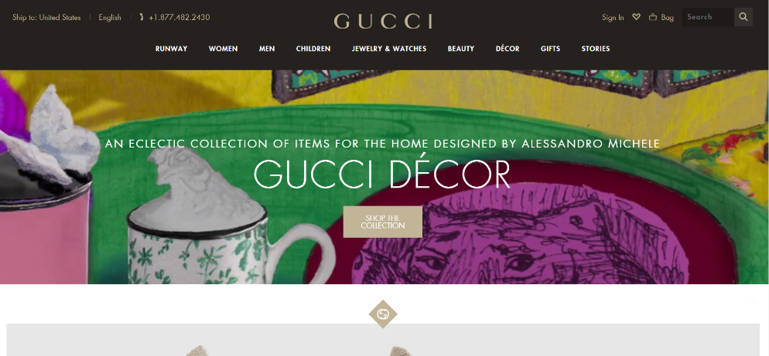

I personally don’t shop at Gucci, but a lot of my friends do. I recently looked at their website, and I really like it for a clothing brand website. The home page is nice and clean and fancy, which is there type of clothing. The men’s and women’s sections are organized. Good colors scheme. Overall a really nice website to help you.

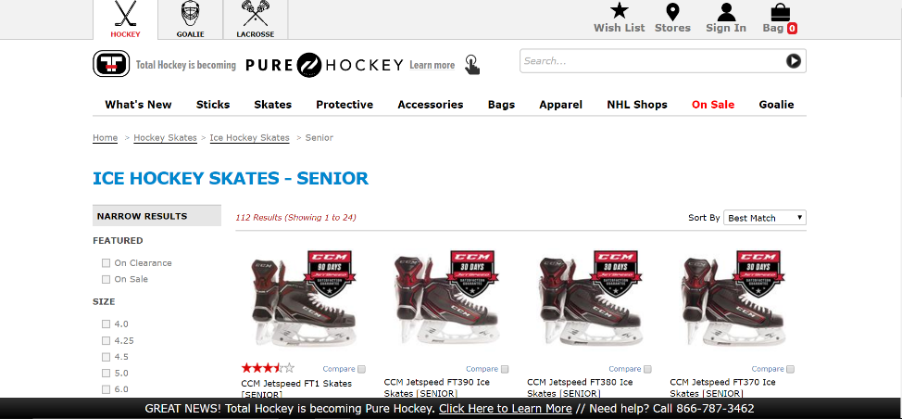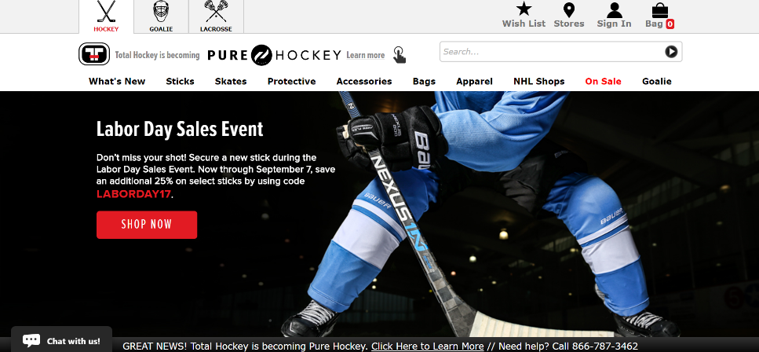

I play Ice Hockey, so buying quality equipment is a must. Pure Hockey is the place I go to buy my equipment. I really like their website because on the home page, a big banner displaying the current sale or event going on pops up. That is always good to see because buyers like sales! Also, the categories are split up nicely, so if you want a specific item for hockey, just go to the category you want.